Productiions table

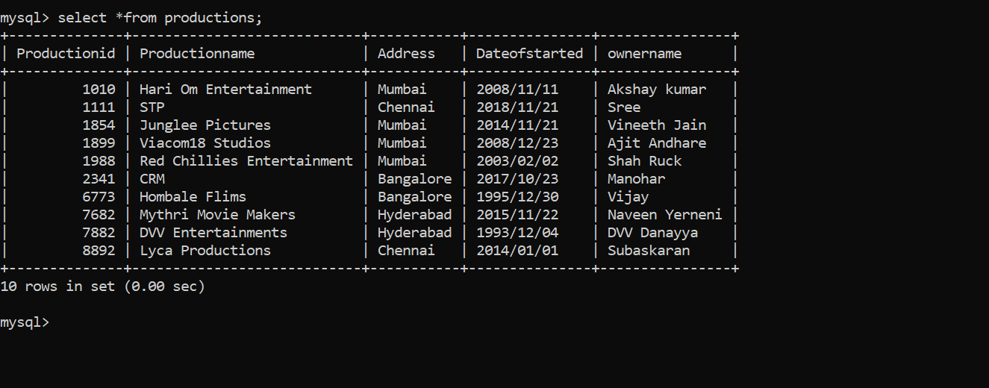

.

1)Write the query to display productionid, production name with total number

movies produced by each.

2.

Write the query to display production name, owner name have produced more

than 2 movies

3.

Write the query to display production name, owner name have produced

maximum movies

4.Write the query to display the heroname acted in the producer name=

’Subaskaran’.

5.

Write the query to display the moviename, heroname whose productionid

ends with 82.

6.

Write the query to display the productionname, ownername who has not

produced the movie.

8.

Write the query name to display the heroinename who acted in the different

productions but not in same production id.



9.

Write the query to display the heroname who acted in maximum languages

